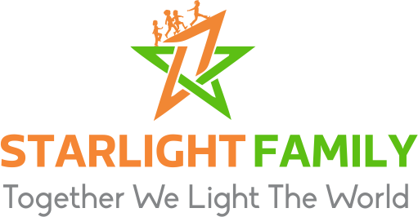
Starlight Family
P.O.Box 89,
Kiboga –Uganda,
East Africa.

www.Starlightfamily.Org

Starlightfamily20@gmail.com (Uganda)
FriendsofStarlightFamilyUK@gmail.com (UK)

COVID 19 Relief Funds Expenditure Report July 2021

Funding Source: GoFundMe fundraiser initiated by Ms. Nirvikalpini Nithya (https://www.gofundme.com/f/uganda-lockdown-crisis-feeding-at-risk-families/)

Amount Received (UGX): 1,548,641/= (one million five hundred forty eight thousand, six hundred forty one shillings only) which is equivalent to 316.6 (GBP)

Background
As Uganda entered its second lockdown once again the most vulnerable families are being effected the hardest. Financial support was sought to help alleviate the suffering and hardship created for vulnerable families in our local communities. Many people have had their sources of income stopped without receiving compensation and many who were reliant on other family members are finding those family members are also in difficulty and unable to provide support. People are lacking food, soap and face masks without which they are not permitted to move around. It is likely that the difficulties faced will continue for some time even after the lockdown restrictions are removed.

Target Communities:
1) Namunyuka-Nakasagazi
2) Bumakya
3) Kikwatambogo
4) Goyero
5) Kabadda

page 1 of 4
Target Beneficiaries:
The Elderly
Orphans
Widowed Mothers,
The Vulnerable Poor within the Community
The Young Single Mothers and Teenagers
HIV Positive Persons
People with Disabilities

Items Procured:

S/N | ITEM | QUANTITY | RATE | AMOUNT UGX /GBP
1 | Maize flour | 360 Kg | 2,200/=@ | 792,000/= | 163
2 | Laundry Soap | 66 Bars | 4,500/=@ | 297,000/= | 61
3 | Salt | 72 Kgs | 2,200/=@ | 144,000/= | 29
4 | Face Masks | 60 pieces | 3,000/=@ | 180,000/= | 37
5 | Packing Materials |  | 10,000/= | 10,000/= | 2
6 | Communication(Airtime and Internet Data |  | 23,045/= | 23,045/= | 4
7 | Transport to and from |  | 100,000/= | 100,000/= | 20
8 | Bank Charges |  | 2,596/= | 2,596/= | 0.6
 | TOTAL |  |  | 1,548,641/= | 316.6

Beneficiaries and Distribution:

S/N | NAME OF  FAMILY HEAD | AGE | SEX | NO. IN  HOUSE  HOLD | VILLAGE | QUANTITY OF ITEMS RECEIVED
 |  |  |  |  |  | Flour kg * | Soap bars | Salt kg | Masks
 | Muankusi  Maria | 81 | F | 4 | Bumakya | 20 | 4 | 4 | 4
 | Ssenoga  Najjibu | 45 | M | 17 | Bumakya | 50 | 9 | 9 | 10
 | Nakato  Jane | 49 | F | 4 | Kikwatambogo | 20 | 4 | 4 | 4
 | Mukaferesi Angelina | 68 | F | 4 | Kikwatambogo | 20 | 4 | 4 | 4
 | Mutesi  Margaret | 24 | F | 5 | Kikwatambogo | 25 | 5 | 4 | 5
 | Ngirarubanda Philip | 78 | M | 1 | Namunyuka | 15 | 2 | 4 | 1

Page 2 of 4
S/N | NAME OF  FAMILY HEAD | AGE | SEX | NO. IN  HOUSE  HOLD | VILLAGE | QUANTITY OF ITEMS RECEIVED
 |  |  |  |  |  | Flour kg * | Soap bars | Salt kg | Masks
 | Maama  Jesca | 42 | F | 10 | Namunyuka | 40 | 7 | 6 | 6
 | Lwabubu  Jacob | 79 | M | 5 | Namunyuka | 25 | 5 | 4 | 5
 | Mariana  Nanziri | 91 | F | 1 | Namunyuka | 15 | 2 | 4 | 1
 | Nyirahabimana Faith | 93 | F | 4 | Namunyuka | 20 | 4 | 4 | 4
 | Dodoviko Sindiyobuza | 80 | M | 1 | Namunyuka | 15 | 2 | 4 | 1
 | Nakasumba Racheal | 36 | F | 4 | Namunyuka | 20 | 4 | 4 | 4
 | Kabugo  Livingstone | 90 | M | 2 | Kikwatambogo | 15 | 4 | 4 | 2
 | Nanfuka  Maria | 88 | F | 2 | Namunyuka | 15 | 2 | 4 | 2
 | Mutamba  Eron | 21 | F | 3 | Namunyuka | 15 | 2 | 4 | 2
 | Namusisi  Jane Francis | 50 | F | 7 | Namunyuka | 30 | 6 | 6 | 5
Totals |  |  |  | 74 People |  | 360 kg | 66 bars | 73 kg | 60 masks

* Please note that distributed food items are estimated to last for approximately 1 month

Challenges and Action Points

There were only enough funds raised to distribute in three of the village communities (Namunyuka- Nakasagazi, Bumakya and KikwataMbogo.) Goyero and Kabadda have not yet been reached.
Even in the three villages that were reached, not all of the persons identified as in need were able to get our help. A few of the most vulnerable families, including the elderly, those headed by young and single mothers, those with People Living with HIV or those with many dependents benefited but we had hoped to be able to reach more. The community outreach has been an eye opener as people who were previously thought of as in an OK position were also seeking our help.
Going forwards we anticipate that the need is still great and we hope to secure more funds in order to meet the urgent needs of everyone identified through our community outreach.

Report Compiled by:

Lukyamuzi James (founder and director) on behalf of the board of directors Starlight Family Kiboga district Uganda.

Date: 26/07/21
page 3 of 4

Highlights

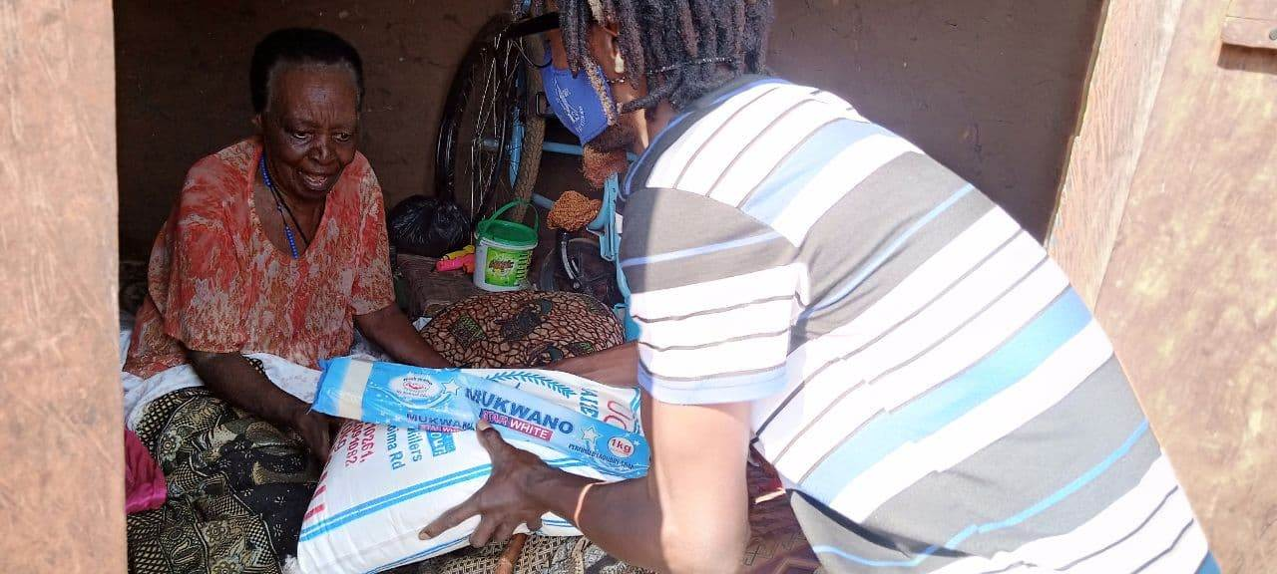 | 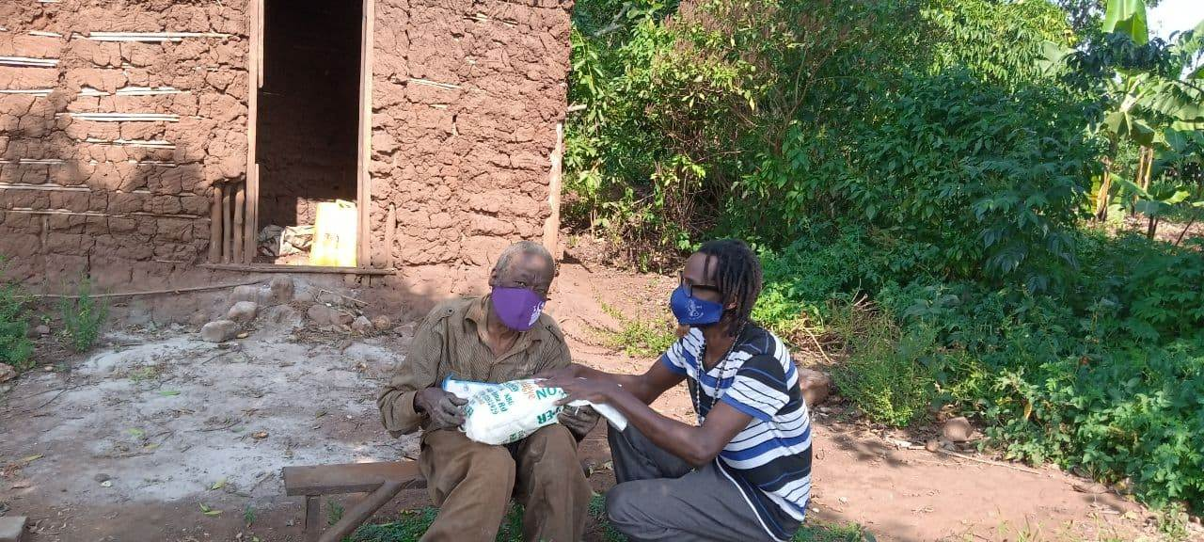 | 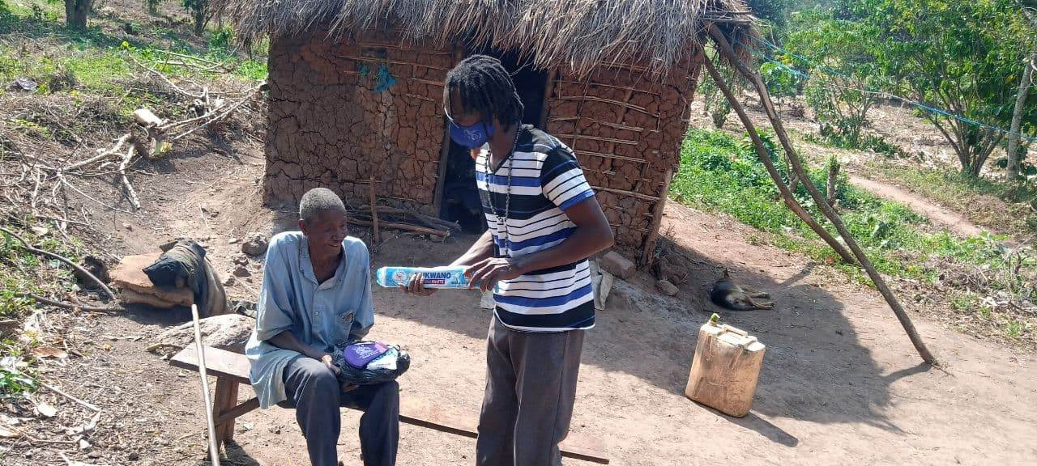
Above: Some of the beneficiaries who received items to their homes as they were unable to get to the main collection point
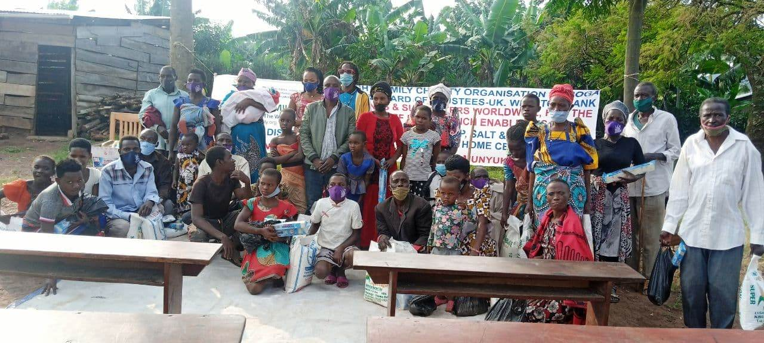 | 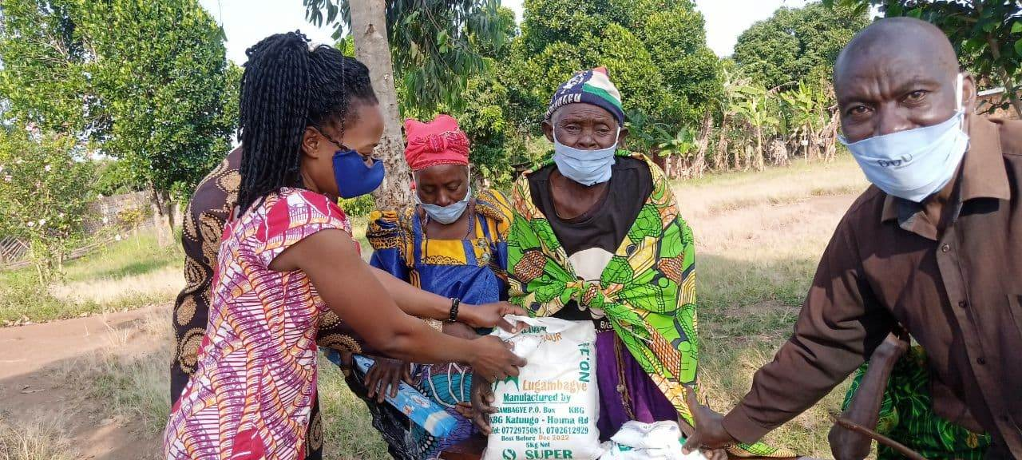 | 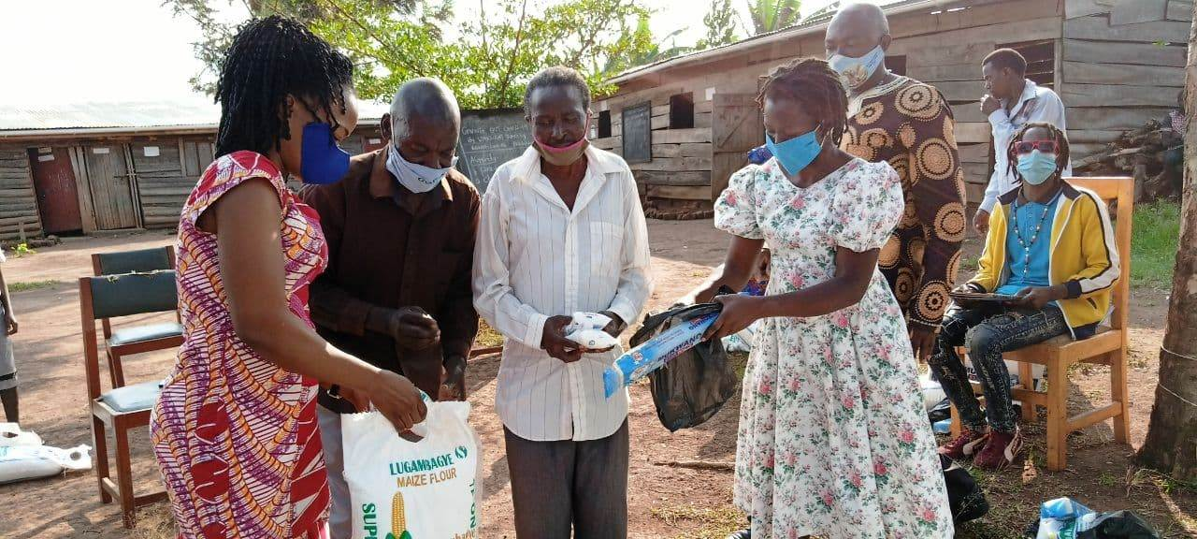
Above: Some of the beneficiaries who were able to collect the items from the school grounds
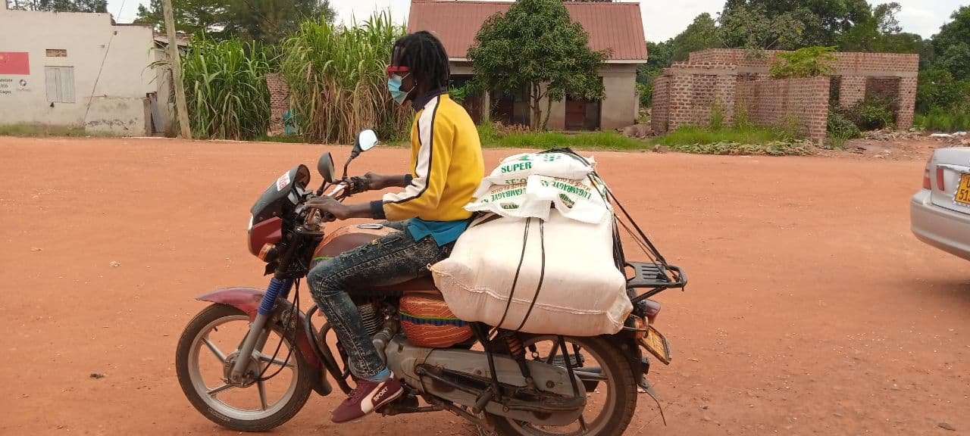 | 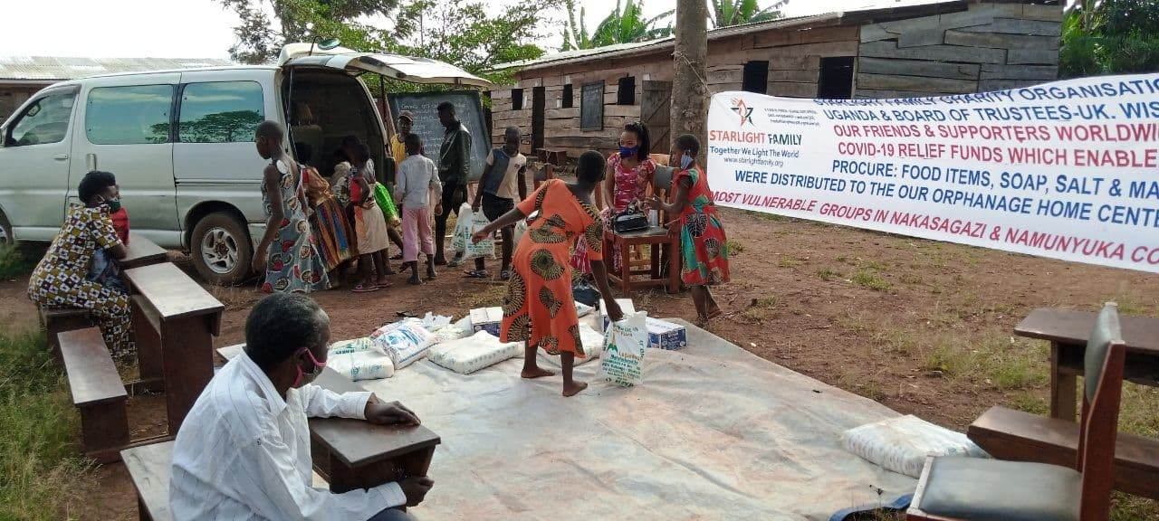 | 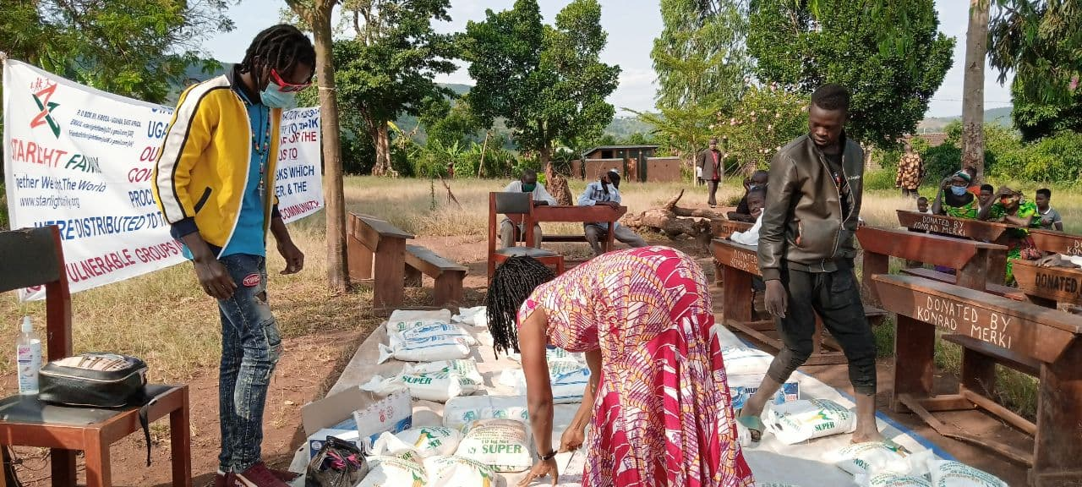
Above: Volunteers collecting and arranging the items
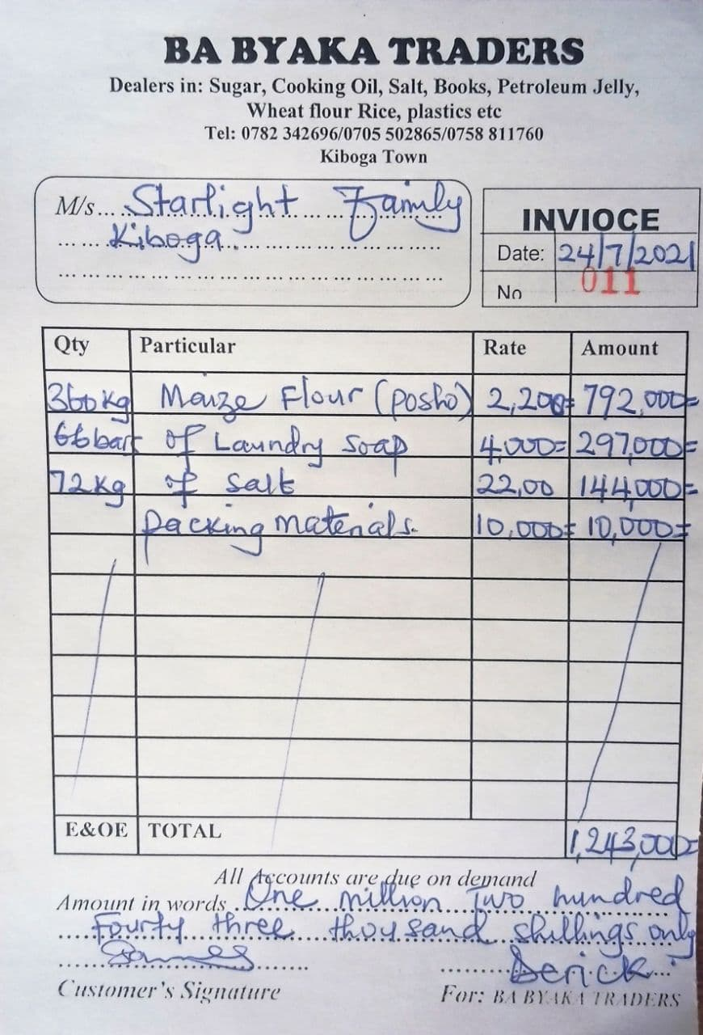 | 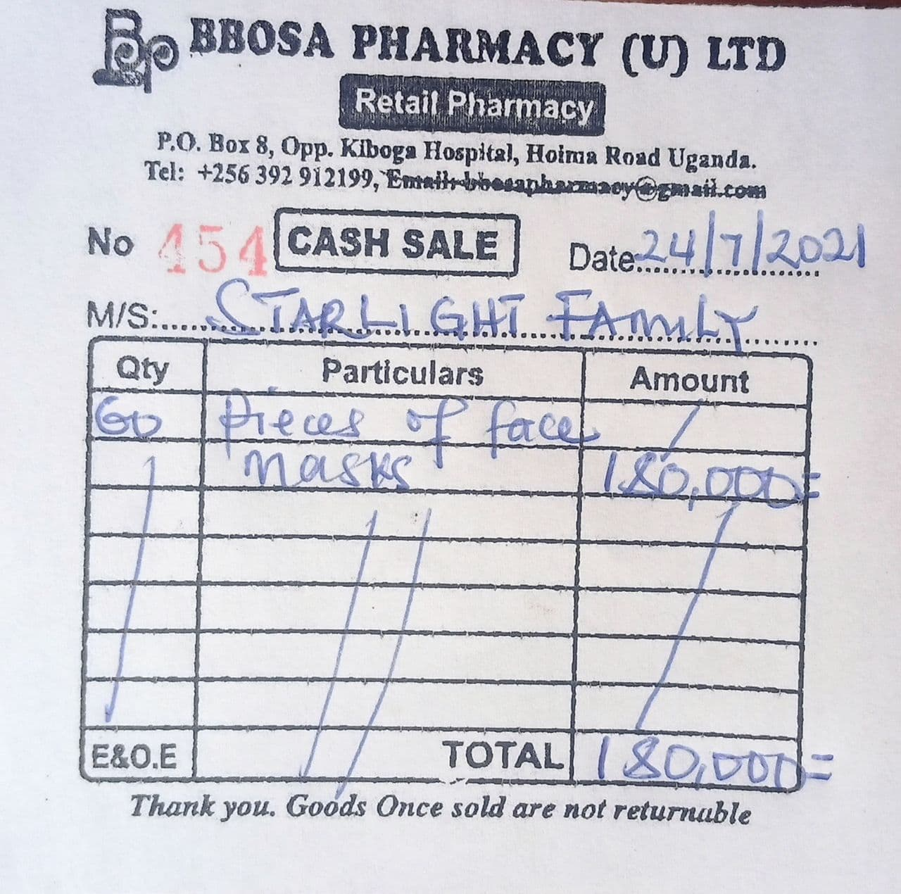 | 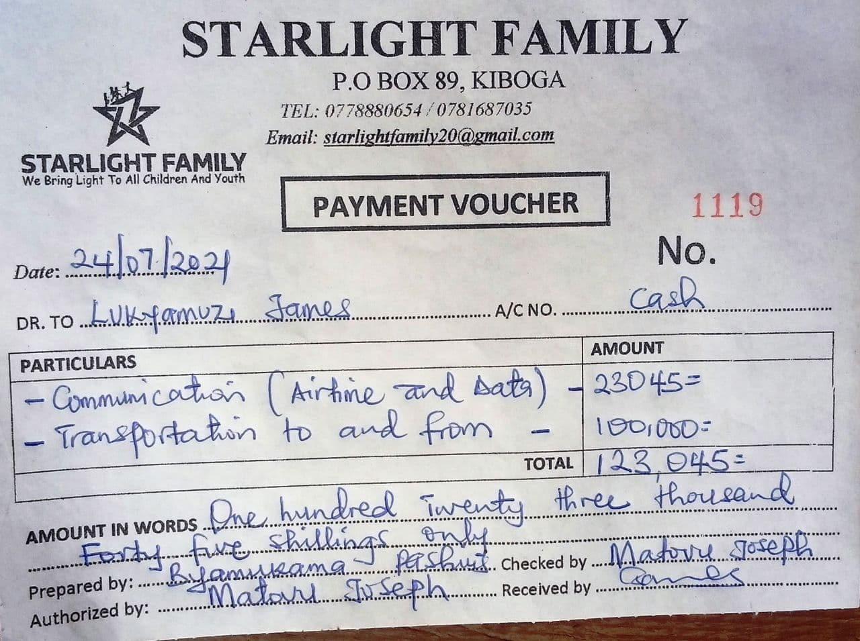
Above: receipts for the items brought and distributed

page 4 of 4

